Today I have checked the detection on some images but after 3759 epoch the model is not predicting anything

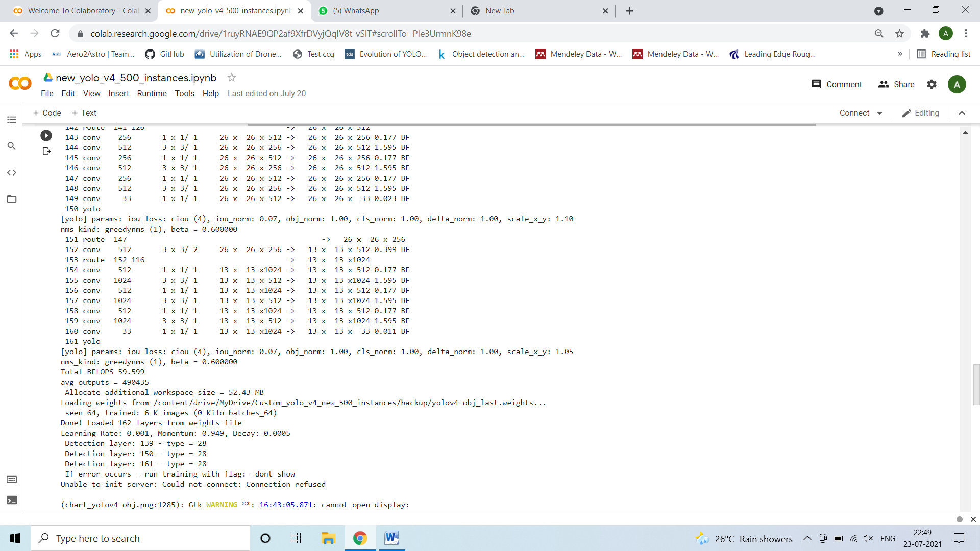

I have used the darknet repo but the results are not saved the result folder.

I am facing this issue during showing the image.

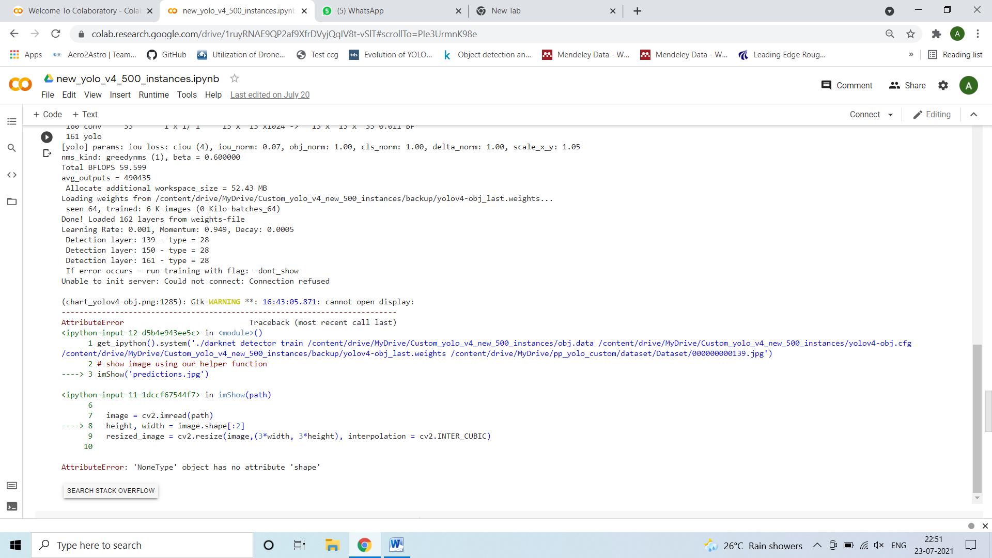

I am figuring out to solve this issue. Might be I have to use some other repo(the ai guy repo) for detection.

Meanwhile I have resumed the training of yolo v4 till 12000. I have saved the weight of 3759 th epoch. Once the error will be solved I will show the output.